Vibration stress relief on metal
Alternative to stress relief annealing

Dulliken / Switzerland - Since 2014, the company WIAP AG Ltd SA has applied for four new patents for the "vibration stress relief on metal" (MEMV) technology. The innovative procedure is utilised in order to reduce stresses in metallic components once again, e.g. the distortion as a consequence of welding processing operations or after heavy rolling. Customary techniques such as stress relief annealing or flame straightening are also applied to such tasks but are mostly energy-intensive or lead to the scaling of the components. In this respect, the MEMV technology offers a few advantages for the user.

The Swiss company WIAP AG has already been successfully dealing with the MEMV technology for a long time. Meanwhile, the supply programme has been comprehensively extended to five basic models: V5 for components with masses up to 5 t, V20 (for 20 t), V50 (50 t), V100 (100 t) as well as V200 for a workpiece weight of 200 t. Moreover, the new developments encompass the multiaxial VS vibrator. This is suitable particularly for welded structures since it can excite all three coordinate directions with just one device. Since it excites all the axial directions, decisively better stress distributions than with conventional biaxial exciters are thus possible with it.

Other new products are also available in the supply programme, e.g. rotating jigs. Several axial directions compared with conventional procedures can be covered with them. All the so-called dead points (or nodal points) are excited. In this way, a uniform stress relief process introduced over the entire component is carried out with the aid of vibration.

WIAP AG has already been dealing with the vibration technology and its advantages since 1983. However, with the aid of complicated measuring procedures from 2014 to 2017, it has only now become possible, for the first time in the firm's history, to provide unambiguous evidence of the concrete benefits. For example, the vibration technology serves to achieve the same results as in the case of stress relief annealing not only with welded structures but now also, due to the extended MEMV procedure, during heavy rolling. This results in decisive advantages for the customer. On the one hand, no scaling arises. On the other hand, it is possible to save an enormous amount of energy: Merely 2 kW/h is necessary for an exemplary process. In contrast, approx. 935 kW/h must be applied during a comparable procedure with stress relief annealing.

Numerous examples from practice prove that the vibration technology functions outstandingly with flame-straightened or hydraulically straightened components - this heralds a new era in the vibration stress relief of components made of metal.

In spite of all the successes already achieved until now, the process is being optimised even further. Above all, that also relates to the peripheral equipment as is shown by the substantially extended accessories programme. For example, there are new multiple clamping jigs with which all the directions and all the zones can be excited in just one clamping operation. The multiple clamping jig is designed in such a way that it can be extended for various component types.

The new WIAP MEMV 20 E generation of control devices is designed in such a way that all the tasks can be performed with just one device depending on the choice of the device - no matter whether manual handling or fully automatic control. The fully automatic machine controls all the directions and all the zones independently in a software-assisted process. Because of the building block principle, the upgrade (for example) from a 5 t device to a 100 t device is possible at a comparatively favourable price. Furthermore, the carefully thought-out concept also serves to reach customers where devices have already been utilised for quite a long time - the older devices are easy to retrofit, right up to the fully automatic machine. WIAP AG also includes such requirements in its concept in order to offer already existing customers a solution viable for the future.

Press contact
Sven Widmer / Iris Widmer,
WIAP AG Ltd SA,
Industriestrasse 48L,
CH 4657 Dulliken, Switzerland
Tel. +41 62 752 42 60
wiap@widmers.info
www.wiap.ch

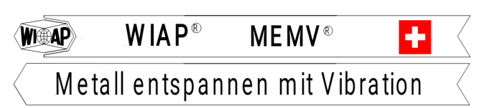

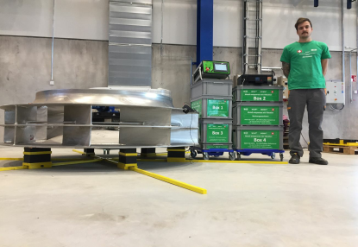
Jim Peter Widmer in Tampere, Finland, in front of a "vibration stress relief on metal" (MEMV) installation from WIAP AG - August 2017 (photographs: hpw - Hans-Peter Widmer)

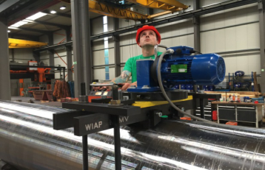
Rolls during vibration stress relief on metal (MEMV) - Jim Peter Widmer - April 2017 (hpw)

