Vibration stress relief on metal
Alternative to stress relief annealing

Fig. 1. Jim Peter Widmer in Tampere, Finland, in front of a "vibration stress relief on metal" (MEMV) installation from WIAP AG - August 2017 (hpw - Hans-Peter Widmer)

Dulliken / Switzerland - Since 2014, the company WIAP AG Ltd SA has applied for four new patents for the "vibration stress relief on metal" (MEMV) technology. The innovative procedure is utilised in order to reduce stresses in metallic components once again, e.g. the distortion as a consequence of welding processing operations. Customary techniques such as stress relief annealing are also applied to such tasks but are mostly energy-intensive or lead to the scaling of the components. In this respect, the MEMV technology offers a few advantages for the user.

The Swiss company WIAP AG has already been successfully dealing with the "vibration stress relief on metal" technology for a long time. Meanwhile, the supply programme has been comprehensively extended to five basic models: V5 for components with masses up to 5 t, V20 (for 20 t), V50 (50 t), V100 (100 t) as well as V200 for a workpiece weight of 200 t. Moreover, the new developments encompass the multiaxial VS vibrator. This is suitable particularly for welded structures since it can excite all three coordinate directions (X, Y and Z axes) with just one device. Therefore, the multiaxial vibrator is simultaneously used for welding while the component is vibrating. Since it excites all the axial directions, decisively better stress distributions than with conventional biaxial exciters are thus possible with it.

WIAP has developed the newest model (a VV with adjustable eccentric stages) in order to be able to counteract not only low frequencies with high exciter stages but also vice versa. In each case, the objective is to reduce the imbalance stage. With this installation, a wide spectrum of applications can be covered in practice without any manual intervention.

Other new products are also available in the supply programme, e.g. the current rotating jigs. Several axial directions compared with conventional procedures can be covered with them. All the so-called dead points (or nodal points) are excited. In this way, a uniform stress relief process introduced over the entire component is carried out with the aid of vibration.

Intensive investigations prove advantages
Contrary to established processes, comparatively younger technologies are the subject of mostly critical scrutiny although the advantages can often be recognised directly. However, the benefits cannot always be proven in a concrete form with figures too. In order to obtain appropriate answers to such critical questions, intensive investigations into what effects vibration stress relief achieves with the components were conducted over several years (from 2014 to 2017). The most diverse comparative measurements were taken for this purpose, not only between annealed and unannealed components but also with flame-straightened and hydraulically straightened components.

No scaling - 400 times less energy
WIAP AG has already been dealing with this technology and its advantages since 1983. However, it has only now become possible, for the first time in the firm's history, to provide unambiguous evidence of the concrete benefits. For example, the vibration technology serves to achieve the same results as in the case of stress relief annealing or even better results not only with welded structures but now also, due to the extended MEMV procedure, during heavy rolling. This results in two decisive advantages for the customer. On the one hand, no scaling arises during the vibration procedure. On the other hand, it is possible to save an enormous amount of energy: Merely 2 kW/h is necessary for this process. In contrast, approx. 935 kW/h must be applied during a comparable procedure with stress relief annealing. Therefore, that entails an energy saving of well over 400 times.

Fig. 2. Sven Widmer in front of a roll - October 2016 (hpw)
Fig. 3. Jim Peter Widmer in front of an annealed roll and an unannealed roll - October 2016 (hpw)
Fig. 4. Treatment process: parts - April 2017 (hpw)
Fig. 5. Rolls during vibration stress relief on metal (MEMV) - Jim Peter Widmer - April 2017 (hpw)
Fig. 6. Sven (left) and Jim Peter Widmer (right) - April 2017 (hpw)
Fig. 7. Duplex pipe test - August 2017 (hpw)

Sven Widmer, Managing Director of WIAP AG, reports on the efforts in the recent past: "In the last few years, all the job work orders were always carried out with two workers instead of with one operator. The background to this measure was to use a comparatively complicated measuring process in order to establish how the stresses in the component can be reduced in an ever more controlled way. For this purpose, a component had to be divided into six measuring points per axis in each case, i.e. six times on the X axis (thus in the longitudinal direction), six times on the Y axis (vertical) as well as six times on the Z axis (transverse)."

The exciter was clamped on the component in different axial directions and the difference in the G value (9.81 m/s²) was subsequently always established at the beginning of the vibration stress relief process compared with the end of the stress relief process.

Fig. 8. Measuring test with the aid of one data logger - October 2016 (hpw)
Fig. 9. Measuring test with one data logger: support annealed - October 2016 (hpw)
Fig. 10. Measuring test with several data loggers including the subsequent protocol - October 2016 (hpw)

Thanks to the new testing method, it was recognisable from the beginning that zones move to a greater or lesser extent - depending on the axial direction. This supplied the finding that all the zones can never be stress-relieved equally with the conventional vibration in a uniaxial direction. According to the latest status of knowledge until now, this means that approx. 60 % of the stresses in the component are reached on average but up to 40 % are correspondingly not reached. Depending on the component type, these remaining 40 % stresses which are not reached may also be less or more.

Furthermore, the high-precision measuring methodology indicated that there are distinct differences in the results of cubic and rotationally symmetrical components. The latest status is that the vibrations reach decisively fewer transverse directions with cubic components. This finding is very valuable and indicates that multidirectional vibration stress relief (called new MEMV) must be utilised, above all, with these components. With foresight, WIAP AG has, from 2014 to today, correspondingly invested approx. CHF 350,000 (i.e. around Euro 300,000) in the intensive investigations into vibration stress relief.

Fig. 11. Sven Widmer during a measuring test with 24 measuring points including the elaboration of the protocol - August 2017 (hpw)

The investigations by means of measuring technology led to a few important findings which can be used both technologically and economically. Firstly, it can be proven that all the zones can only be excited with the multidirectional (MEMV) procedure. Secondly, it is shown that it is completely unnecessary to utilise any excitation which causes high deflections. In the case of the heavy rolls, the G excitation operations were, in part, even only particularly fine. Nevertheless, these rolls "behaved" like an annealed rool during the subsequent finishing.

Flame-straightened / hot-straightened components
The list of components with which the procedure offers high benefit potentials can be extended comprehensively. Flame-straightened pipes with a length of 12 m (for instance) may be cited as another example. These were straightened for torsion and the curvature was also bent straight by several millimetres. Tests showed that the pipes subjected to annealing were distorted back into a curved position after the cooling.

Fig. 12. Sven Widmer during a measuring test with 24 measuring points including the elaboration of the protocol - August 2017 (hpw)
Fig. 13. Flame straightening: MEMV vibration test with the elaboration of the protocol (hpw)

In contrast, the pipes stress-relieved with the new MEMV technology remained straight - the subsequent processing did not distort them even by a tenth of a millimetre! When the flame-straightened (non-annealed / non-vibrated) components were processed, these were once again curved by several millimetres after the processing. The measurements provided the evidence that vibration stress relief serves to reduce the stresses precisely where they are too. In contrast, a zone is elongated with flame straightening while the yield strength is not exceeded in any other zones. Thus, the component no longer goes back to the home position. Although it remains straight (subject to targeted specialist and intelligent handling), even very high stresses which cannot be reduced are nevertheless "trapped" in the interfacial zones in part. With the MEMV procedure, it is no problem to "touch" these zones and to correspondingly compensate for them in this way. All in all, the numerous examples from practice show that the vibration technology functions outstandingly with flame-straightened or hydraulically straightened components - this heralds a new era in the vibration stress relief of components made of metal.

Accessories extended comprehensively
In spite of all the successes already achieved until now, the people responsible at WIAP AG are aware that additional tests and experiences from practice are necessary in order to optimise the process even further. Above all, that also relates to the peripheral equipment as is shown by the accessories programme which has been extended substantially in the last few years.

Fig. 14. New V20 exciter with various setting possibilities in % for different eccentric stages - October 2017 (hpw)

The clamping of the exciter alone provided numerous new findings. Simple screw clamps are, so to speak, a thing of the past and are currently the clamping method which is technically rather unsuitable and is the last choice. One decisive element for a successful process is a stable clamp which does not vibrate in itself. As a consequence of this, there are more than 50 new clamping solutions in the supply programme in the meantime and a large number of others will still be added in order to be able to cover all the customer applications.

Fig. 15. Clamping jig in the axial direction for one impeller - August 2017 (hpw)
Fig. 16. Star floor holder for rubber pads - August 2017 (jw - Jim Peter Widmer)
Fig. 17. Star rubber floor holder with an axial exciter fastening jig - August 2017 (hpw)
Fig. 18. Floor rubber holder for a multiple star floor holder - August 2017 (hpw)

Multiple clamping jig
Fig. 19. Three impellers with a diameter of 800 mm on one multiple clamping jig, Tampere, FI - August 2017 (hpw)
Fig. 20. Six cylindrical pipes on one multiple clamping jig, Berlin - August 2017 (hpw)
Fig. 21. Multiple clamping jig, customer part from Thommen in Safenwil - October 2017 (hpw)
Fig. 22. Impellers on one multiple clamping jig in Tampere, FI - August 2017 (jw)

Until now, small parts with masses under 100 kg have still been regarded as less suitable for vibration stress relief. WIAP AG took this circumstance as an opportunity to develop a new multiple clamping jig with which all the directions and all the zones can be excited in just one clamping operation. The multiple clamping jig is designed in such a way that it can be extended for various component types. For example, long thin components should be provided with extreme deflection on the entire component, i.e. not only in the upper zone, and only small deflection at the fastening point. All the zones of a component should be excited in all the axial directions. All these points were taken into account in the case of the current design and have been incorporated into the newly developed WIAP multiple clamping jigs.

WIAP MEMV 20 E control device
Fig. 23.WIAP MEMV E control device, Safenwil (hpw)
Fig. 24. WIAP MEMV control device with a printer and boxes, Tampere, FI - August 2017 (jw)
Fig. 25. WIAP MEMV 20E control device, Tampere, FI (jw)
Fig. 26. WIAP MEMV control device with the V20 exciter in the background, Tampere, FI - August 2017 (jw)
Fig. 27. WIAP MEMV control device: display on the screen - July 2017 (jw)
Fig. 28. MEMV measuring probes - July 2017 (jw)

The new WIAP MEMV 20 E generation of control devices is designed in such a way that all the tasks can be performed with just one device depending on the choice of the device - no matter whether manual handling or fully automatic control. The fully automatic machine controls all the directions and all the zones itself in a software-assisted process. The different construction sizes, no matter whether the 5 t device or the 200 t device, are covered with the aid of a box for additional devices. In this respect, it was important to WIAP that, above all, the key components are all uniform. Only the tasks of the larger inverter are performed via the box for additional devices with the controller of the electrics of the rotating jig, electronics etc. Because of this building block system, the upgrade (for example) from a 5 t device to a 100 t device is possible at a comparatively favourable price. Furthermore, the carefully thought-out concept also serves to reach customers who have already utilised devices for quite a long time - the older devices are easy to retrofit, right up to the fully automatic machine. WIAP AG also includes such requirements in its concept in order to offer already existing customers a solution viable for the future.

Less stress with vibration stress relief
Already in earlier years, WIAP AG recognised the advantage of the stress relief procedure described in greater detail here in the case of its own machine tools. The many years of experiences in combination with the findings from the current complicated tests are now uniting such a high quality that, in the meantime, they can be utilised in a modern production plant in an absolutely targeted way, e.g. in the construction of high-precision machine tools. WIAP AG wants to pass on the knowledge about the enormous possibilities of the procedure and to make it available to other users too in order to push ahead with the development permanently.

Press contact
Sven Widmer / Iris Widmer,
WIAP AG Ltd SA,
Industriestrasse 48L,
CH 4657 Dulliken, Switzerland
Tel. +41 62 752 42 60
wiap@widmers.info
www.wiap.ch

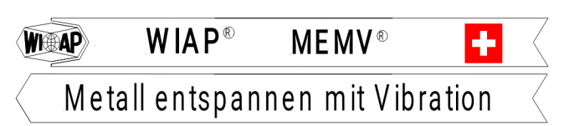

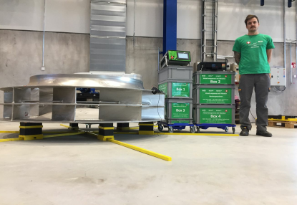
Fig. 1. Jim Peter Widmer in Tampere, Finland, in front of a "vibration stress relief on metal" (MEMV) installation from WIAP AG - August 2017 (hpw - Hans-Peter Widmer)

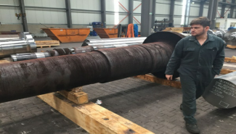
Fig. 2. Sven Widmer in front of a roll - October 2016 (hpw)

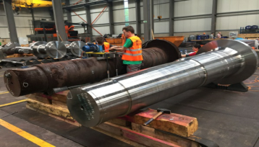
Fig. 3. Jim Peter Widmer in front of an annealed roll and an unannealed roll - October 2016 (hpw)

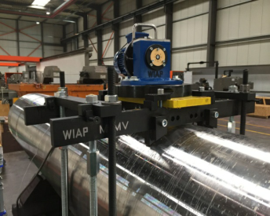
Fig. 4. Treatment process: parts - April 2017 (hpw)

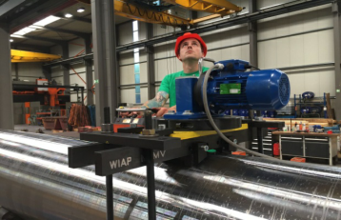
Fig. 5. Rolls during vibration stress relief on metal (MEMV) - Jim Peter Widmer - April 2017 (hpw)

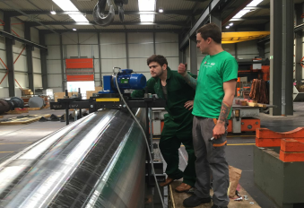
Fig. 6. Sven (left) and Jim Peter Widmer (right) - April 2017 (hpw)

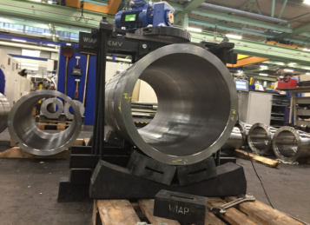
Fig. 7. Duplex pipe test - August 2017 (hpw)

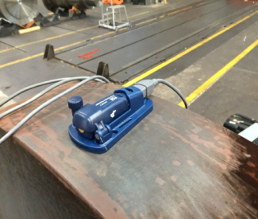
Fig. 8. Measuring test with the aid of one data logger - October 2016 (hpw)

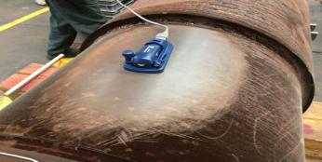
Fig. 9. Measuring test with one data logger: support annealed - October 2016 (hpw)

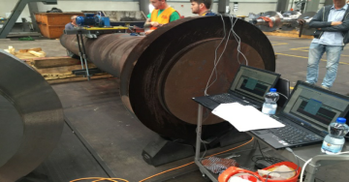
Fig. 10. Measuring test with several data loggers including the subsequent protocol - October 2016 (hpw)

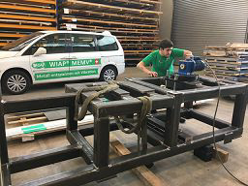
Fig. 11. Sven Widmer during a measuring test with 24 measuring points including the elaboration of the protocol - August 2017 (hpw)

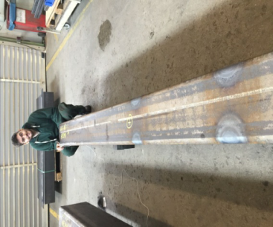
Fig. 12. Sven Widmer during a measuring test with 24 measuring points including the elaboration of the protocol - August 2017 (hpw)

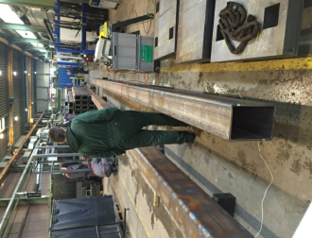
Fig. 13. Flame straightening: MEMV vibration test with the elaboration of the protocol (hpw)

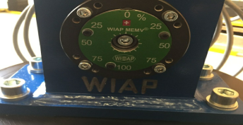
Fig. 14. New V20 exciter with various setting possibilities in % for different eccentric stages - October 2017 (hpw)

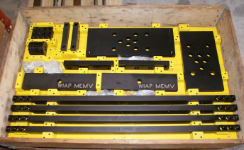
Fig. 15. Clamping jig in the axial direction for one impeller - August 2017 (hpw)

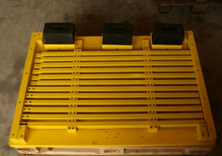
Fig. 16. Star floor holder for rubber pads - August 2017 (jw - Jim Peter Widmer)

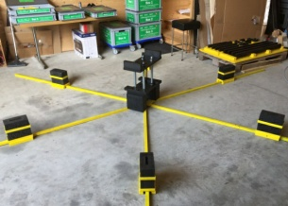
Fig. 17. Star rubber floor holder with an axial exciter fastening jig - August 2017 (hpw)

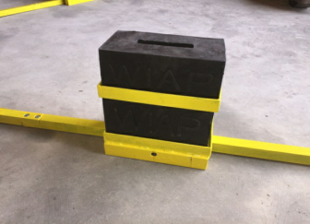
Fig. 18. Floor rubber holder for a multiple star floor holder - August 2017 (hpw)

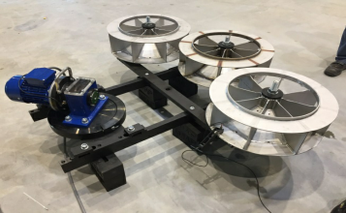
Fig. 19. Three impellers with a diameter of 800 mm on one multiple clamping jig, Tampere, FI - August 2017 (hpw)

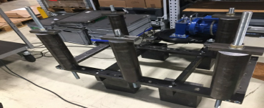
Fig. 20. Six cylindrical pipes on one multiple clamping jig, Berlin - August 2017 (hpw)

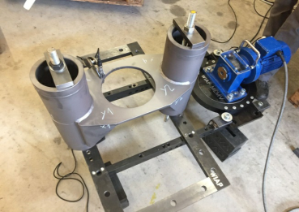
Fig. 21. Multiple clamping jig, customer part from Thommen in Safenwil - October 2017 (hpw)

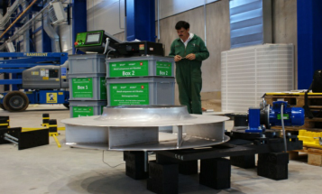
Fig. 22. Impellers on one multiple clamping jig in Tampere, FI - August 2017 (jw)

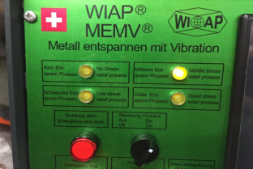
Fig. 23.WIAP MEMV E control device, Safenwil (hpw)

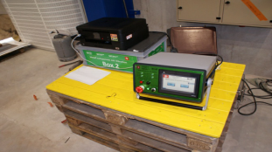
Fig. 24. WIAP MEMV control device with a printer and boxes, Tampere, FI - August 2017 (jw)

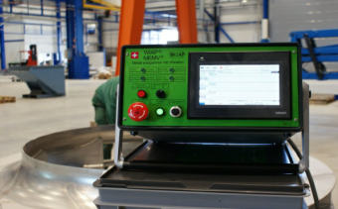
Fig. 25. WIAP MEMV 20E control device, Tampere, FI (jw)

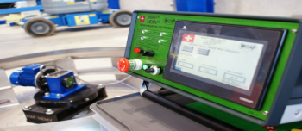
Fig. 26. WIAP MEMV control device with the V20 exciter in the background, Tampere, FI - August 2017 (jw)

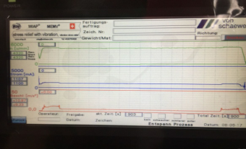
Fig. 27. WIAP MEMV control device: display on the screen - July 2017 (jw)

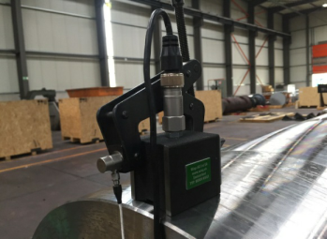
Fig. 28. MEMV measuring probes - July 2017 (jw)

