Bericht WM 886 Spannungen messen
POLDI Neutronen Diffractometer

Poldi: «Neutronen Diffractometer»

Neutronen Spannungen Messen

POLDI: A Materials Science Time-Of-Flight Neutron Diffractometer
POLDI (Pulse OverLap DIffractmeter) is a time-of-flight thermal neutron diffractometer, dedicated to materials science applications. In particular POLDI is well suited for:
- Spatially resolved measurements of residual stresses in engineering components
- Study of stress/temperature induced phase transformations
- In-situ deformation studies of metallic systems
POLDI is operated by the NIAG group of the Laboratory for Neutron Scattering and Imaging.

POLDI: Ein Materialwissenschaftliches Flugzeit-Neutronen-Diffraktometer
POLDI (Pulse OverLap DIffractmeter) ist ein thermisches Neutronen Diffraktometer, das speziell für Anwendungen in der Materialwissenschaft entwickelt wurde. Insbesondere ist POLDI gut geeignet für:
• Ortsaufgelöste Messungen von Eigenspannungen in technischen Bauteilen
• Untersuchung von stress- / temperaturinduzierten Phasenumwandlungen
• In-situ-Verformungsuntersuchungen metallischer Systeme
POLDI wird von der NIAG-Gruppe des Labors für Neutronenstreuung und Bildgebung betrieben

Contact
Instrument responsible
Tobias Panzner
Phone: +41 56 310 4342
E-mail: tobias.panzner@psi.ch
Instrument co-responsible
Steven Van Petegem
Phone: +41 56 310 2537
E-mail: steven.vanpetegem@psi.ch

The Laboratory for Neutron Scattering and Imaging (LNS) at the Paul Scherrer Institute is responsible for the scientific exploitation, operation and development of neutron scattering and imaging instruments at the Swiss Spallation Neutron Source (SINQ). The team of 50 senior scientists, postdoctoral researchers and PhD students further collaborates on diverse research projects ranging from modern topics in condensed matter physics and materials science to pressing questions in energy research and health care. read more

PhD, Master, Bachelor or Semester projects at the LNS
We offer students the possibility to do their PhD or educational research in our lab. See Teaching and Education for detailed information on Master/Diploma thesis, Bachelor/Semester work and practical courses at the LNS. Currently we have open positions for
- Semester projects on several topics
- Master project - Elastic properties in low dimensional quantum systems
- Master project - Spontaneous magnon decay in non-collinear antiferromagnets
- Master project - Geometrical magnetic frustration beyond insulating ionic compounds
- Master project - Magnetic order in anisotropic triangular materials
- Master project - Magnetic structure of the quantum trimer compound Cs₃Cu₃Cl₈OH

News
12. February 2018
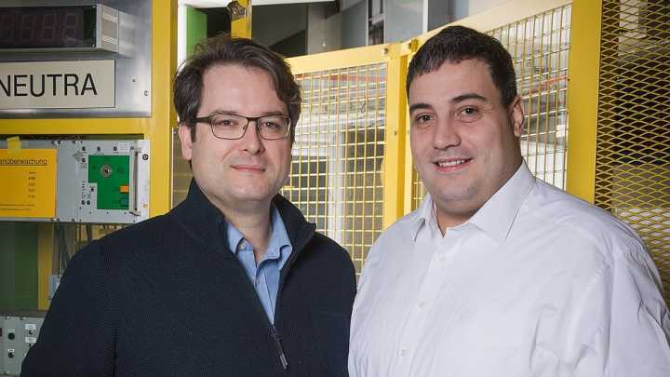

Imaging at Paul Scherrer Institute helps to increase production at ABB site in Aargau
The ABB facility in Wettingen, Aargau, got practical recommendations on increasing output in the manufacture of ceramic components. The ceramics in question are voltage-dependent resistors used in overvoltage protectors – a kind of lightning protection system – for example in electrical transmission lines. Researchers of the Laboratory for Neutron Scattering and Imaging at the Paul Scherrer Institute PSI examined the components by means of neutron imaging. With the help of these images, ABB employees were able to see where there was potential for further process optimisation. This investigation took place within the framework of a feasibility study funded by Hightech Zentrum Aargau. PSI Media Release
11. December 2017
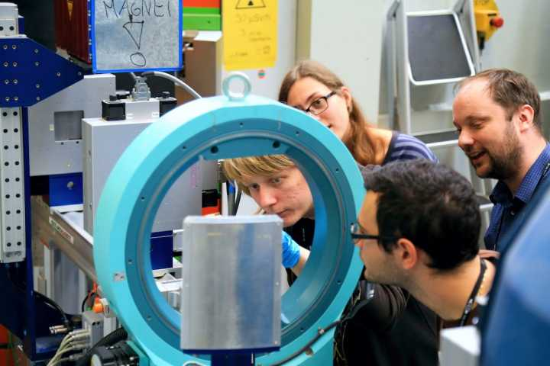

SwedNess Students visit PSI for hands-on training in neutron scattering
To take full advantage of the upcoming European Spallation Source facility ESS, strategic funding has been allocated to rebuild and expand the Swedish neutron scattering community. One of the most important actions is the establishment of the Swedish national graduate school in neutron scattering (SwedNess). Up to 40 PhD students will be fully funded, employed and trained within this school. In the end of September 2017, the first 20 PhD students arrived at the Paul Scherrer Institute (PSI) and the Swiss Spallation Neutron Source (SINQ) for their very first hands-on training in neutron scattering. During their week at PSI the SwedNess students obtained specific training in neutron reflectometry as well as neutron and x-ray imaging. The training was very much appreciated by the students and PSI looks forward to welcoming them back in a near future as scientific users of the SINQ neutron facility.
15. November 2017
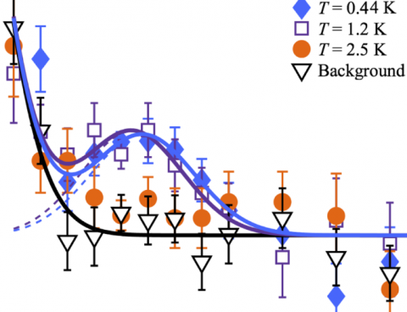

Spin Resonance and Magnetic Order in an Unconventional Superconductor
D.G. Mazzone et al., Physical Review Letters 119, 187002 (2017). Unconventional superconductivity in many materials is believed to be mediated by magnetic fluctuations. It is an open question how magnetic order can emerge from a superconducting condensate and how it competes with the magnetic spin resonance in unconventional superconductors. Here we study a model d-wave superconductor that develops spin-density wave order, and find that the spin resonance is unaffected by the onset of static magnetic order. This result suggests a scenario, in which the resonance in Nd_{0.05}Ce_{0.95}CoIn₅ is a longitudinal mode with fluctuating moments along the ordered magnetic moments.
17. October 2017
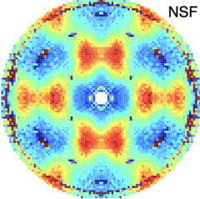

Coulomb spin liquid in anion-disordered pyrochlore Tb₂Hf₂O₇
R. Sibille et al., Nature Communications 8, 892 (2017) (full article). The charge ordered structure of ions and vacancies characterizing rare-earth pyrochlore oxides serves as a model for the study of geometrically frustrated magnetism. The organization of magnetic ions into networks of corner-sharing tetrahedra gives rise to highly correlated magnetic phases with strong fluctuations, including spin liquids and spin ices. It is an open question how these ground states governed by local rules are affected by disorder. Here we demonstrate in the pyrochlore Tb₂Hf₂O₇, that the vicinity of the disordering transition towards a defective fluorite structure translates into a tunable density of anion Frenkel disorder while cations remain ordered. Quenched random crystal fields and disordered exchange interactions can therefore be introduced into otherwise perfect pyrochlore lattices of magnetic ions. We show that disorder can play a crucial role in preventing long-range magnetic order at low temperatures, and instead induces a strongly fluctuating Coulomb spin liquid with defect-induced frozen magnetic degrees of freedom.

13.03.201811:00 - 12:00WHGA/121

Superconductivity in twisted bilayer graphene
Seminar CMT
Jyong-Hao Chen (CMT)
Formularbeginn
Formularende
14.03.201814:00 - 15:00WHGA/121

Hyperfine structure of heavy muonic atoms
Seminar LTP
Niklas Michel (MPI Heidelberg)

Noch zu Integrieren Neue Methode zur Vermessung von Neutronen | Paul Scherrer Institut ...
https://www.psi.ch/media/neue-methode-zur-vermessung-von-neutronen
02.10.2015 - Klaus Kirch, Laborleiter Teilchenphysik am PSI, an einem Testaufbau zur Messung des elektrischen Dipolmoments des Neutrons. Die Forschenden haben eine neue Methode entwickelt, ultrakalte Neutronen zu vermessen. Diese kann womöglich bei der Erklärung helfen, weshalb beim Urknall deutlich

Quellenverzeichnis

Int_ Nasser Kanani
http://de.stresstechgroup.com/content/de/1041/1671/Barkhausenrauschen%20Analyse.html
Praktikumsanleitung Versuch - Lehrstuhl Metallische Werkstoffe
http://www.mat-tec.ch/de/services/eigenspannungen.html
https://www.psi.ch/sinq/poldi/
http://wiap.ch/Diverse%20Sprachen/Deutsch/1.%20Ingalt%2000/Inhalt%2000.htm
Wikipedia NDE
http://stressvision.com/

Ende Bericht WM 886, Spannungen messen
Hpw 07_11_2018

