Report WM measure voltages 886
Cut - Compliance Method

Cut-compliance method

With the cut-compliance (CC) method, was instrumental in the development of Mat-Tec (and is) the Self-voltage gradients across an entire cross-section of a component can be measured efficiently and reliably. For more details, please refer to publications (PDF):
Some Steps Towards Automation of the Crack Compliance Method to Measure Residual Stress Distributions, ICRS5, 1997
Experimental Determination of Crack Closure by the Cut Compliance Technique, in: Advances in Fatigue Crack Closure Measurement and Analysis, ASTM STP 1343, 1999
These can be determined directly the course of the crack stress due to the internal stresses in the form of the course of the stress intensity factor. This is required for fracture-mechanical fatigue and lifetime calculations. Thus the CC method is also suitable for determining Rissschliesseffekte experimentally (PDF:Characterization and assessment of the fatigue crack behavior in the area of ​​the threshold value),
The CC method can be traced to a certain depth to apply (PDF as a part-destructive method for determining residual stresses:Near-surface stress measurement in 2D and 2D by the cut compliance technique, Material Science Forum, 2002), Thus, self-voltages can be measured on larger objects in situ. The CC method is currently an ASTM standard being prepared in the Drafting Committee and serves on the Mat-Tec AG.
Example of a residual stress measurement and determination of the resulting stress intensity factor in a forged shaft

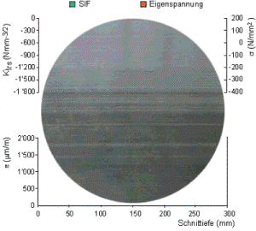

References

Int_ Nasser Kanani
http://de.stresstechgroup.com/content/de/1041/1671/Barkhausenrauschen%20Analyse.html
Internship Manual test - Chair Metallic Materials
http://www.mat-tec.ch/de/services/eigenspannungen.html
https://www.psi.ch/sinq/poldi/
http://wiap.ch/Diverse%20Sprachen/Deutsch/1.%20Ingalt%2000/Inhalt%2000.htm
Wikipedia NDE
http://stressvision.com/

End report WM 886, measure voltages
Hpw 07_11_2018

